### **SPRINT 4**

Natural Disasters Intensity Analysis and Classification using Artificial Intelligence

**TEAM MEMBERS:**

412419104051-KAVANA RAO Y

412419104012-ARCHANA K

412419104128-SUDHARSHINY T A

412419104045-JOE MARIAM.J

412419104107-SAUJANYA K

**c_check_earthquake.py:**

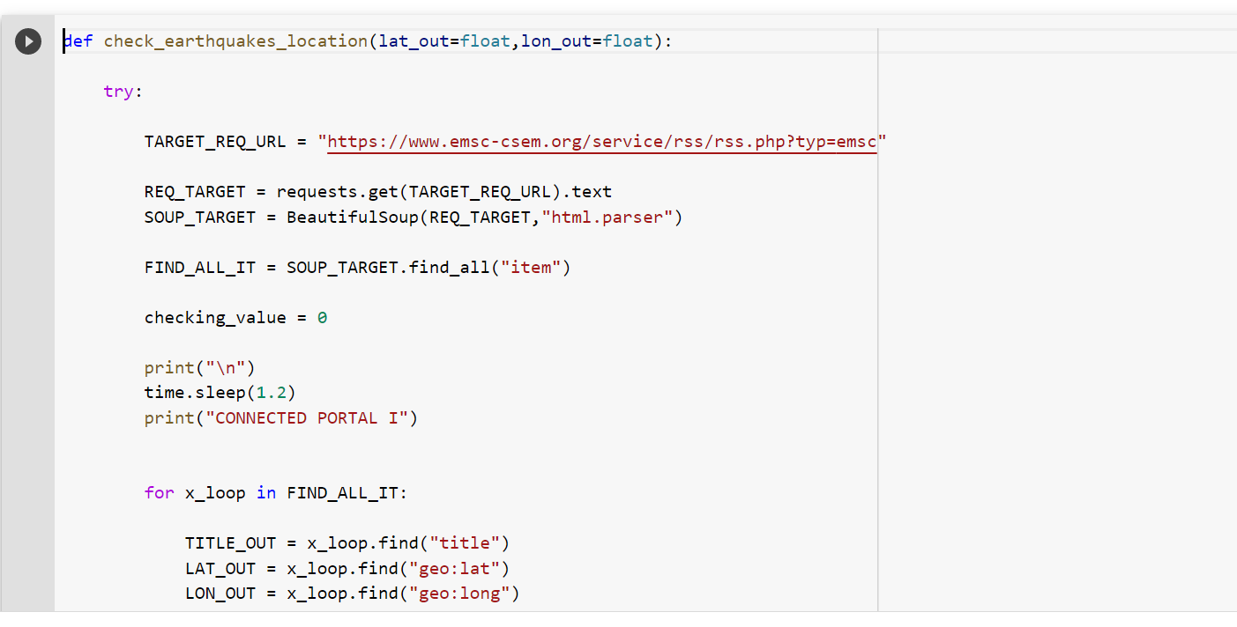

**C_earthquake_g.py:**

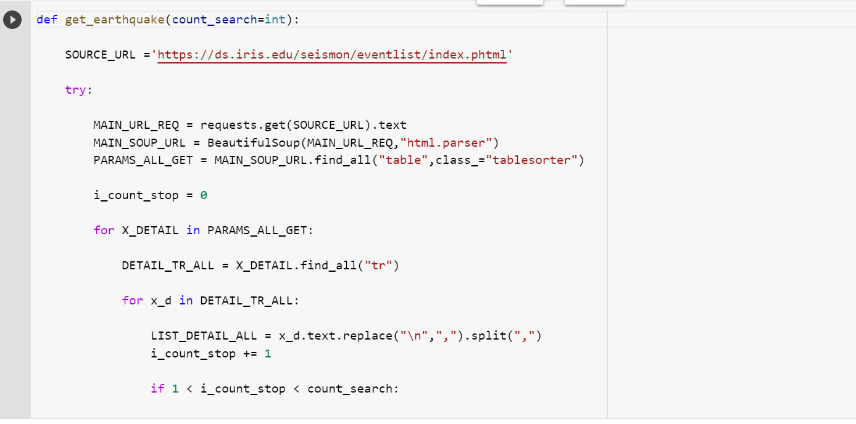

**c_alternative_earthquake.py:**

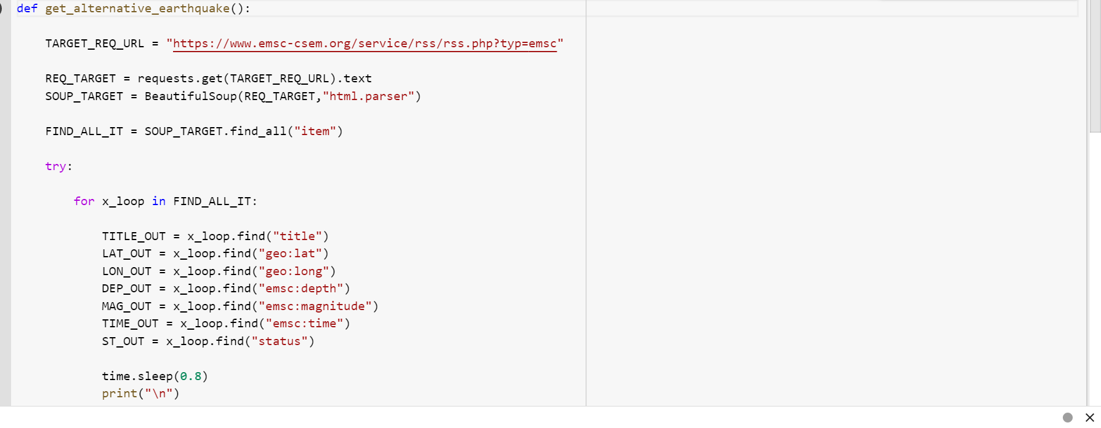

**C_flood.py:**

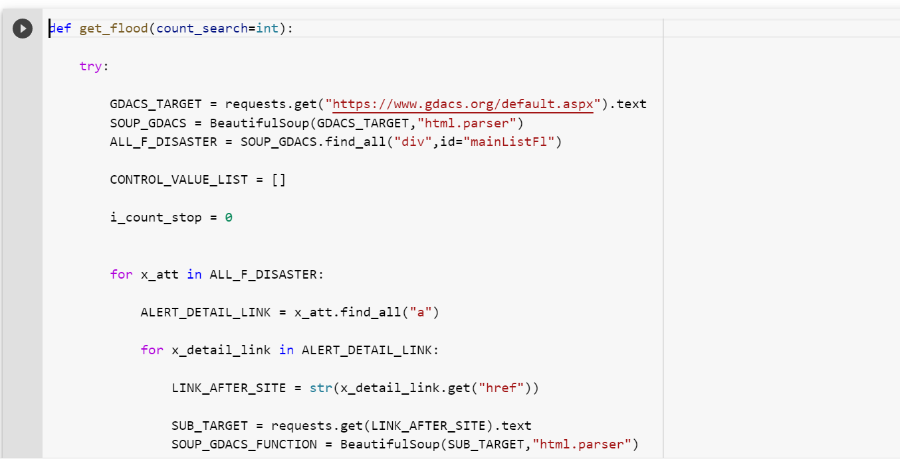

**c_help.py:**

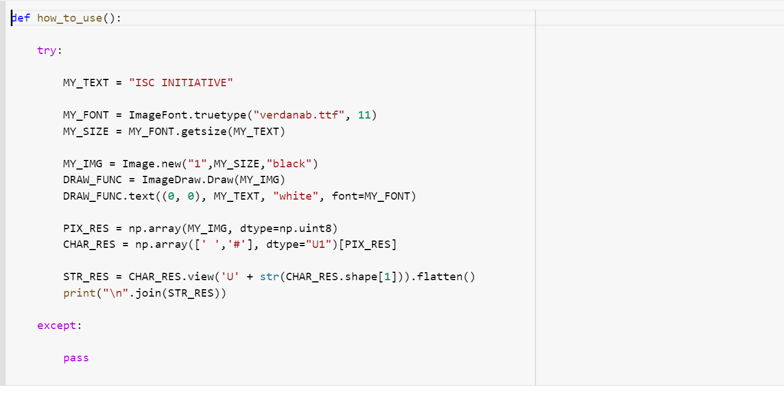

**c_import.py**

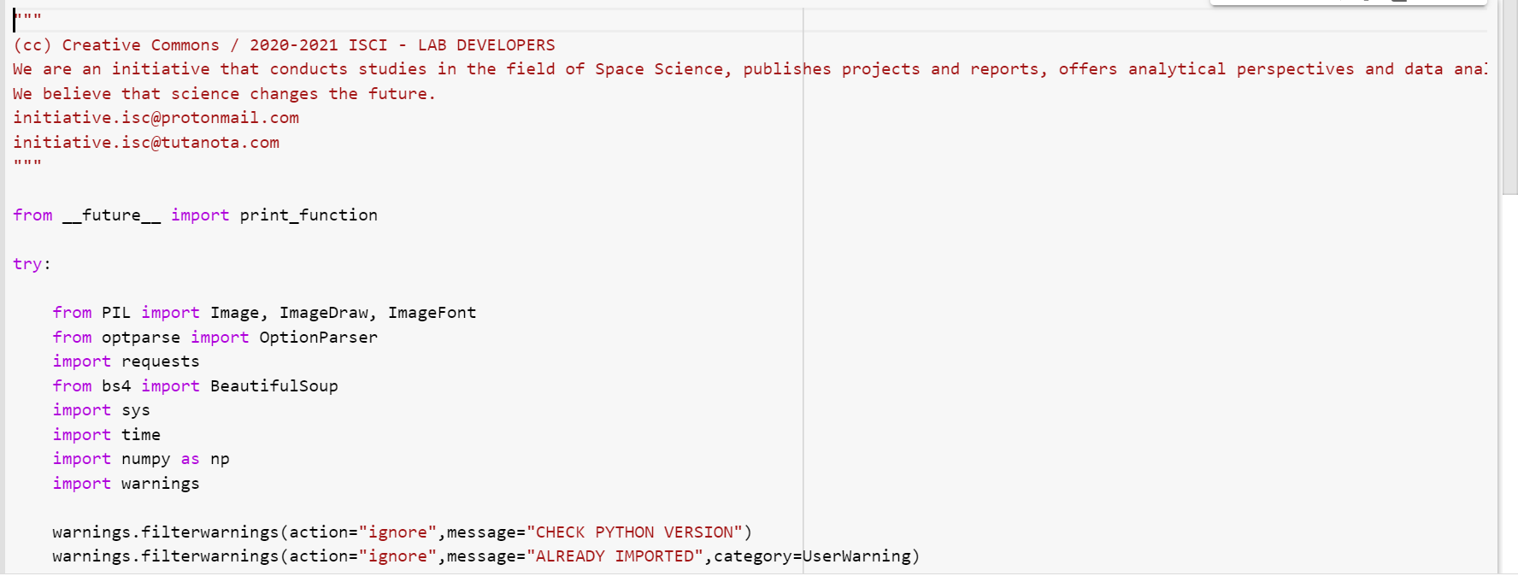

**C_local_alert:**

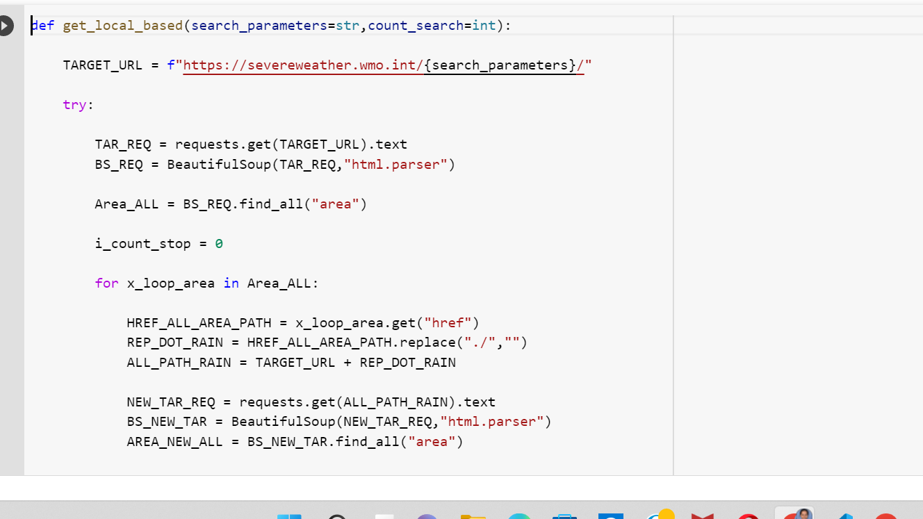

**C_nasaoent.py:**

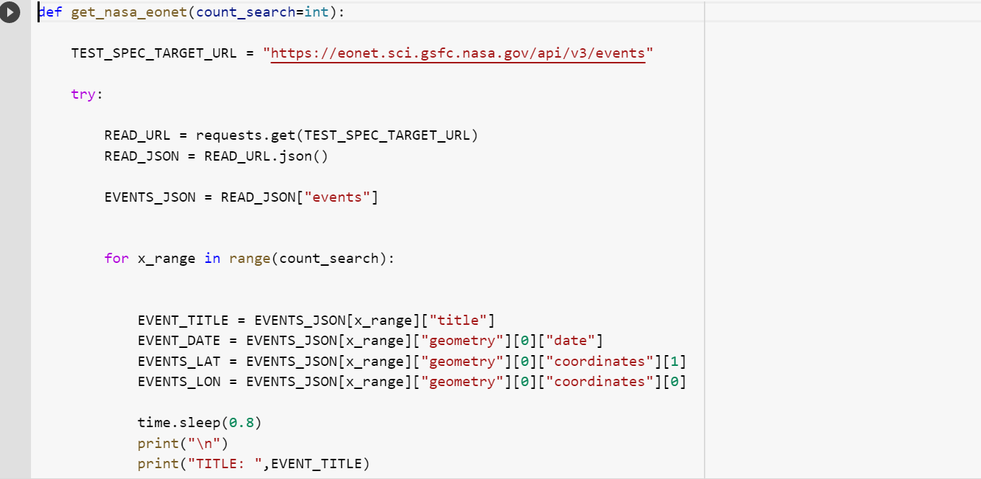

**c_seismic.py:**

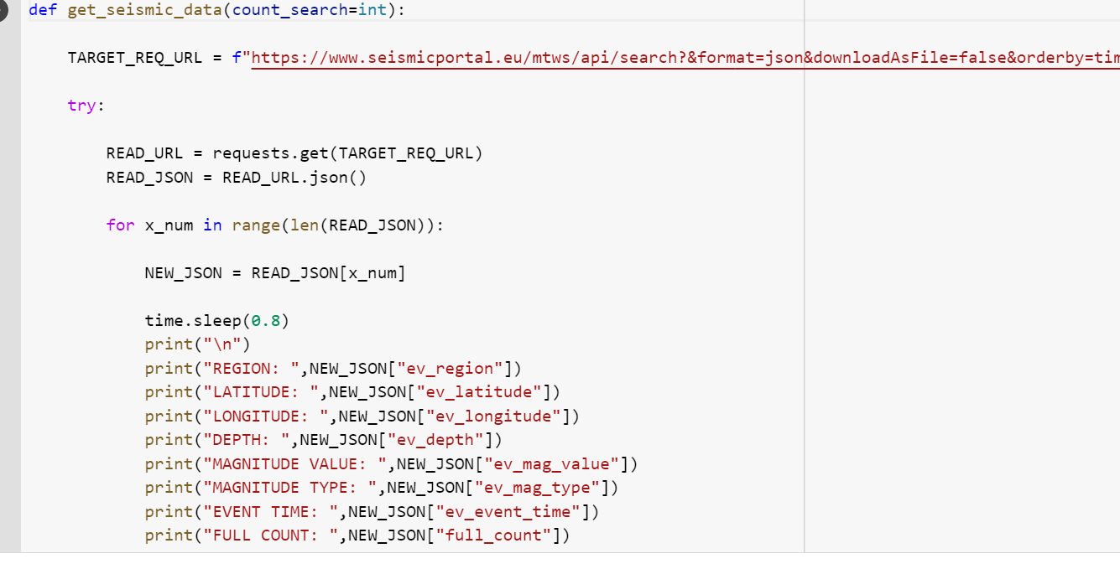

**C_valcano_g:**

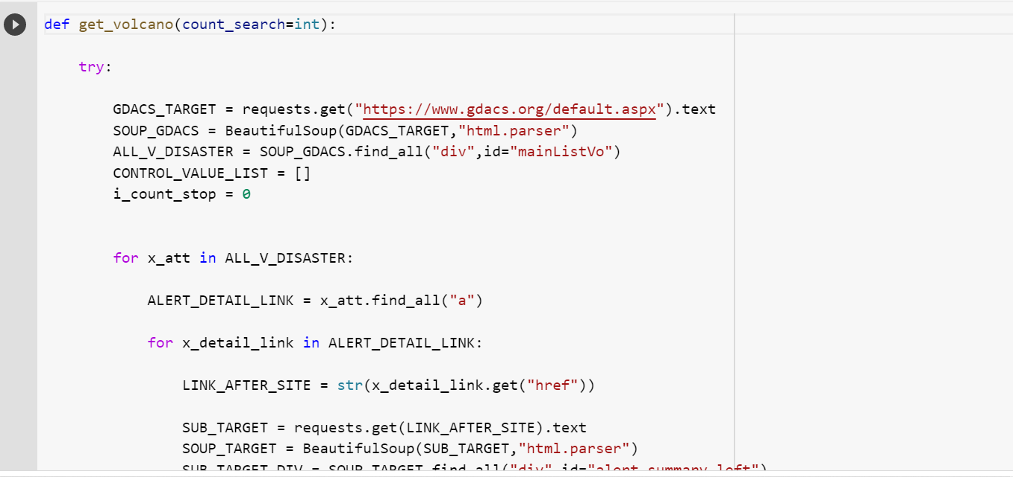

**C_valcano_alternative:**

